1.1-1.5

1.1 1.2

Enumeration枚举

The rule sum: 如果一号任务可以以N种方法被做，二号任务有M种方法被做，那么做其中一个任务的方法有M+N种

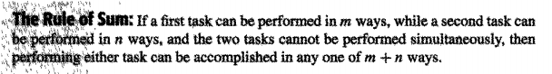

例如40本书关于C++50本书关于JAVA，那么学生就有90种方法选出一个C++ OR JAVA书

The rule of product

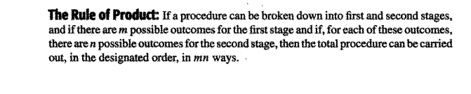

一个进程被分成两个阶段，第一个阶段n种方法，第二个阶段m种方法，总共完成这个进程有mn种方法

Permutation排列组合

*Permutation：不同物体并且顺序重要*

*比如从8个不同球中按不同顺序插入4个槽就是8P4,*

*又比如，1，2，3，4，5能组合出几种排列组合， 5P5*

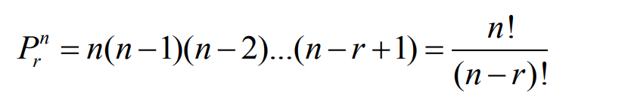

顺序重要的相同物体： 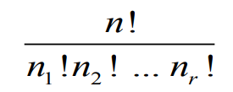，比如需要3个K两个H

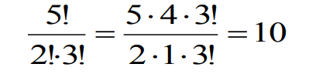

*Combination rule:顺序不重要的时候*

*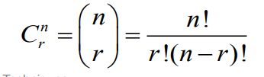*

可以把它想象成插槽问题

例题

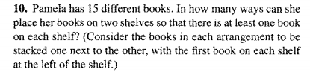

Regardless of shelf, it is a permutation problem, there are 15P15 ways to place them with a special sequence

Then there are 14 ways to put a divider in the sequence

14\*(15P15)=14\*15!= 1.8307441e+13

就是左右各有一本书且顺序重要，换书柜等于插槽， 我们先用15P15求出排列方式，再X14就是插槽能放的位置

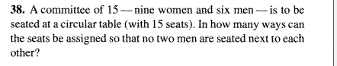

Place women firstly

9!/9=8! (cause the table is circle) //九个女人有顺序排列 9P9 除以9因为是圆的 //九个槽放九个人

Then at every women right hand side, there will be a free seat for 6 man to seat //九个槽放六个人顺序重要

So it is 9P6 (sequence matters), ways for man sequence

8!\*(9P6)=8!\*60480= 2438553600

1.3 Binomial Theorem

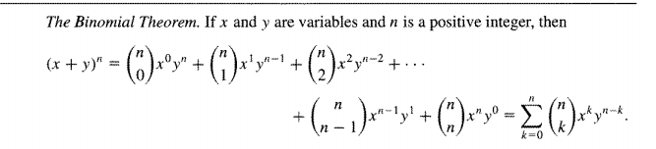

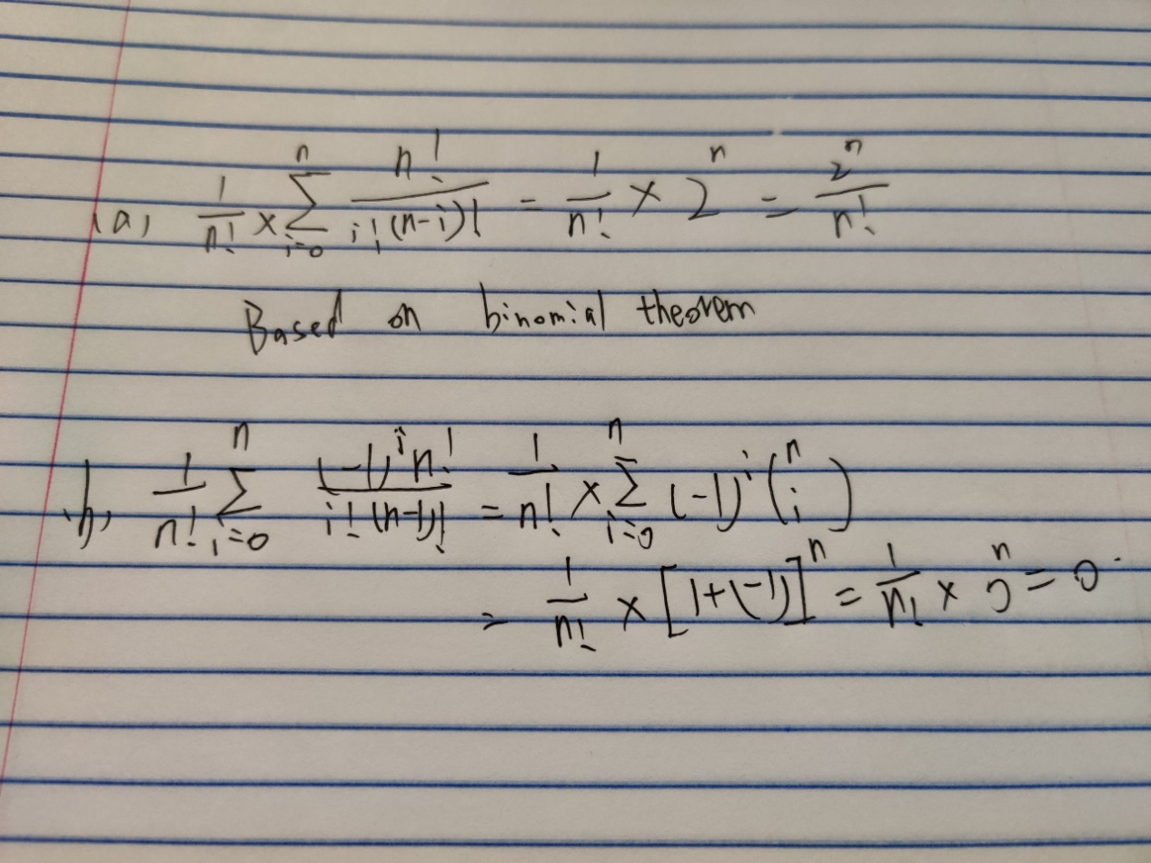

例题

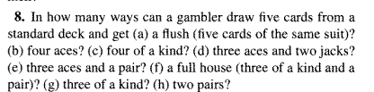

顺序不重要的5个选13个

(a)5 number from 13 (sequence doesn’t matter)

(13C5)\*4= 1287\*4= 5148

(b)4 aces and 1 random

4C4\*48=48

(c)13 kind \* 1 from rest

13C1\*48=624

(d)3 aces from 4 and 2jacks from 4

4C3\*4C2=24

(e)3 aces from 4 \* a pair from 12(cause there are no enough ace) \* 2 from a pair   
4C3\*12\*4C2=228

(f)3 from a kind \* a pair from 12 \* 13kinds \*2 from a kind

228\*13=3744

(g)this question is not clear

The rest 2 can be 1 kind: 3 from a kind \* 2 from other 48 =4C3\*13\* 48C2=58656

The rest 2 cannot be 1 kind: 3 from a kind \*1 from other 48 \*1 from other 44 /2 (the rest 2 has a sequence order) =4C3\*13\*48C1\*44C1/2=54912

(h)2 from 4 \* a suit from 13 \* 2 from 4 \* a suit from rest 12 /2(pair choose has a sequence order)\*the rest 1 from 44

4C2\*13\*4C2\*12/2\*44=123552

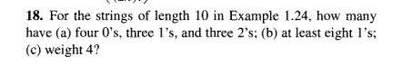

Question 18

1. It is different kinds of identical items permutation so it is 10!/(4!\*3!\*3!) =4200

顺序重要的不同组相同物体

1. Take eight 1 for example, we need to pick 8 space to put 1 ,then the rest 2 can be012, so

10C8\*2^2+10C9\*2+10C10

1. 4=4\*1+6\*0=2\*2+8\*0=2\*1+1\*2+7\*0

10!/(4!\*6!)+10!/(2!8!)+10!/(2!\*1!\*7!)=615

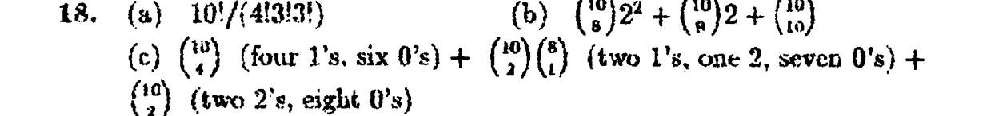

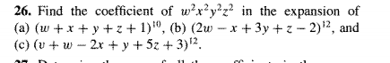

Question 26

1. Pick 2 w 2x 2y 2z 2 ‘1’ 这个就是不同组相同物体问题 （顺序重要， 例如wxyz1wxyz1与wyz1x…得到过程不一样）

10!/(2!\*2!\*2!\*2!\*2!)=113400

1. Pick 2\*‘2w’ 2\*‘-x’ 2\*3y’ 2\*z’ 4\*’-2’

12!/(2!\*2!\*2!\*2!\*4!) \*(4\*1\*9\*1\*2^4)=718502400

1. Wxyz is same as b, and there is no v, so we need 4 ‘3’

12!/(2!\*2!\*2!\*2!\*4!)\*(1\*4\*1\*25\*3^4)=1.010394\*e+10

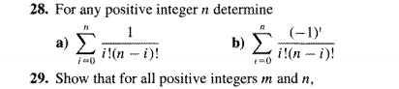

这是一个变形题目

Question 28

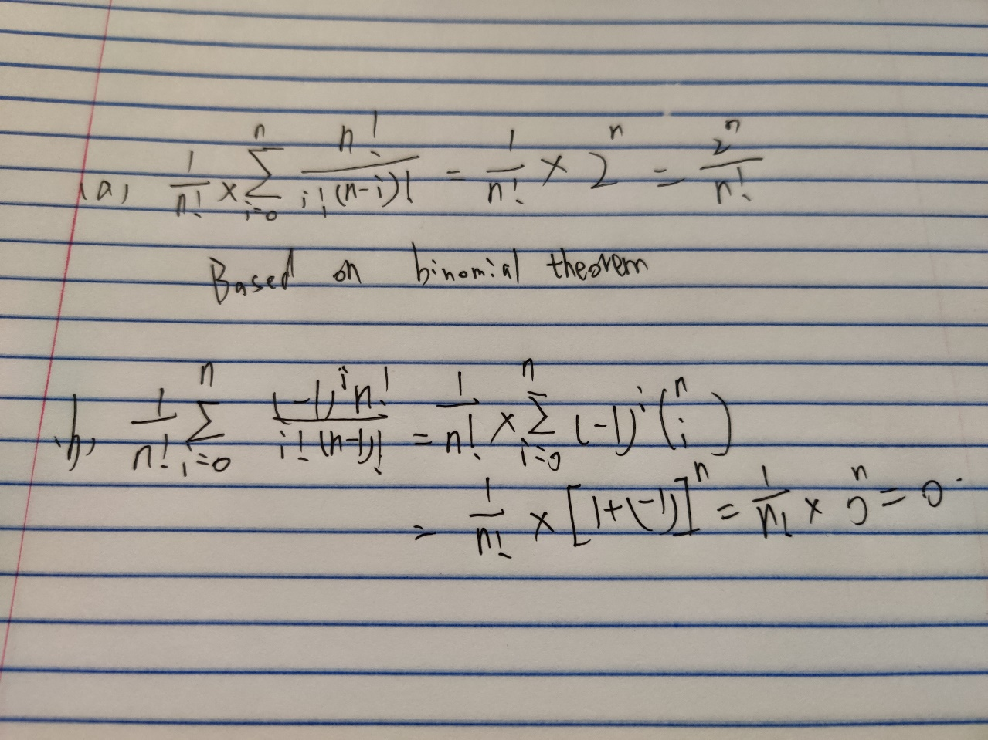

Don’t know how to type sigma so I take a photo

For a, it is just binomial theorem

For b, it is a binomial theorem for (1+(-1)) ^n, then its expansion will be Nc0\*1^n\*-(1)^0+….

+NcN\*1^0\*(-1)^n

第一个上面×n! ，这个吊东西就变成了C(n,i) 一直从0加到n，括号里面带入(1+1)^n展开就是这个

就是2^n

第二个同样，不过括号里带入的是（1-1）^n这样奇数项就可以由负数

1.4 combinitions with repetition

那种有重复的combinition

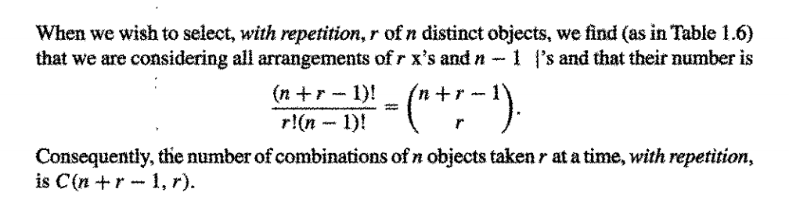

R要选的总数量,n要选的物品可能种类，意思就是有n种物品可选，然后你随机选出R个，有几种可能，注意了这不是顺序重要的相同物体，这时顺序不重要的组合问题，比如你要选10个a or b，可以1个a9个b，也可以2个a8个b

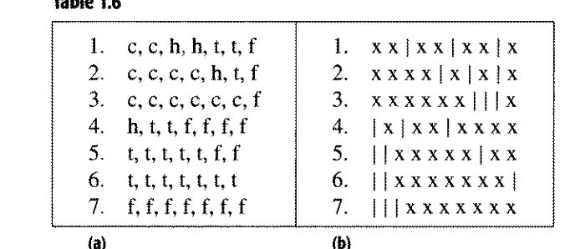

这种问题可以看作间隔问题，如果要选N类，就有N-1个间隔，X+n-1间隔本质上就是空槽，然后摆间隔，填充X

例子

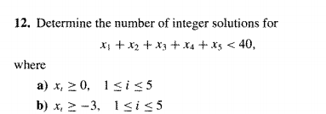

Question 12

1. x1+x2+x3+x4+x5<=39

if we think +1 is item x

then the question will become

xxxx|xxxxx|xxxxx|xxxx|xxxxx|xxxxxxxxxx

x1 x2 x3 x4 x5 the rest

there 39 x to pick, cause it is less or equal than, we need another divider (the last divider) for situation ‘less than’

then the question will become 39 item and 5 divider

44C5=1086008

<先要转成小于等于， 小于等于是39item和5 divider因为我们要划分出一个rest来，如果就是等于，那么就是39item和4divider

1. consider yi=xi+3>=0

x1+x2+x3+x4+x5<=39

y1+y2+y3+y4+y5<=54

then the question is similar to (a)

54 item and 5 divider

59C5=5006386

如果小于0了，那么我们需要凑一个>=0的

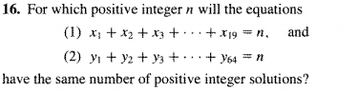

Question 16

this question is same to the XXX|XXX|XXXX|XXXXX stuff in question 12

cause every solution must be positive integer

then we need yk=xk-1

then the question will become

y1+y2+y3+……y19=n-19

y1+y2+y3+….y64=n-64

(n-19+19-1)C(n-19)=(n-64+64-1)C(n-64)

(n-1)C(n-19)=(n-1)C(n-64)

n-19+n-64=n-1 // this step is cause nCk=nC(n-k)

2n-83=n-1

N=82

就没啥可说的，一切都要转到0，因为0才能让divider排到最左or最右

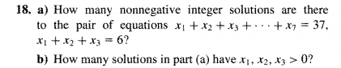

Question 18

(a)//注意下面的数是种类-1,代表着divider

x4+x5+…x7=31

4 kinds with 31 items

(31+4-1)C3=5984

Then we need possible x1x2x3

X1+x2+x3=6

3 kinds with 6 item

(3+6-1)C6=28

5984\*28=167552

(b) yk=xk-1>=0

x1+x2+x3=6

y1+y2+y3=3

3 kind with 3 item

(3+3-1)C2=10

10\*5984=59840

1.5